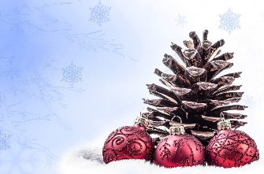 

**NEW YEAR’S EVE MENU**

**179.00 euros without drinks**

**GLASS OF CHAMPAGNE WITH APPETIZER**

**HOMEMADE HALF-COOKED DUCK « FOIE GRAS »**

**CHUTNEY AND CARAMEL SPICES**

**FRENCH SCALLOPS CARPACCIO**

**WITH FRENCH BLACK TRUFFLE MELANOSPORUM**

**HALF LOBSTER « A LA PLANCHA » OUT OF IT SHELL**

**WITH A FULL-BODIED JUICE**

**FENNEL AND TARRAGON RISOTTO**

**FRENCH BEEF FILLET WITH « FOIE GRAS » SAUCE**

**SEASONAL VEGETABLES**

**TRUFFLE CHEESE « BRIE DE MEAUX »**

**SALAD WITH WALNUT OIL**

**EXOTICS FRUITS TARTARE, PASSION SORBET**